1. Will the converge condition value increase in the iteration process? Not stable will affect the converge speed?. And how about the different between the real value and converged result?

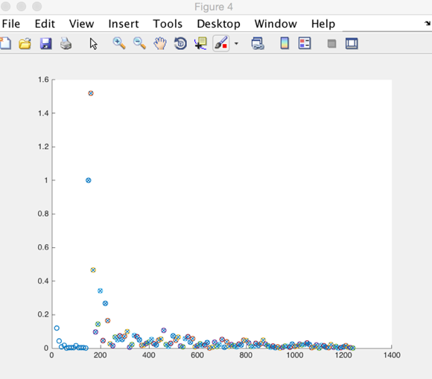

(1)abs(likhood/prevLikhood-1)

If it has increase, how to set the minimal value of condition?(10^-5 in paper how to set

this value?) And how to judge it actually has converge?

1. MAP compared with ML algorithm (online compared with batch EM)? Accuracy? Stability?



(2a) Target Gaussians (2b) ML estimation(batch EM)

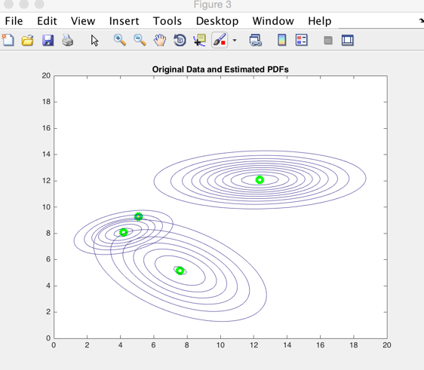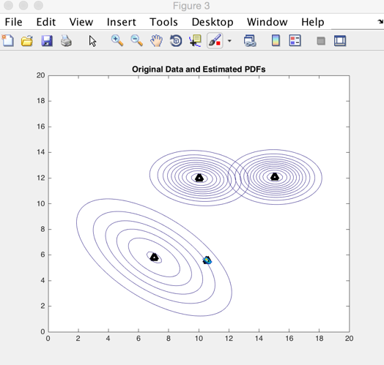

(2c) MAP estimation (online EM) (2d) ML estimation(batch EM)

1. Implementation: g.mean.x

Why not use g.x1/g.statsW directly?

If crit = 1-> g.x1/g.statsW？





1. Likelihood is not same with what mentioned on paper? Is there any reason





1. Offline->online

What’s n(offline+online observed samples?) in the equation

What’s meaning of the offline procedure? How many samples should be added in this part?

1. Experiments(a b v m k)

How to adjust the parameters in experiments to make them the most suitable values for the application? Is there any specific method?